Cosmos System

Overall vision

Summary

Historic 4

Conception 4

Guidelines 4

System Versions 5

Current users and metrics 7

Current users 7

Some metrics 7

Functional Vision 9

The main modules 9

• Cosmos Gestor de Secretarias 9

• Cosmos Gestor de Conferências 9

• Cosmos Gestor Financeiro 9

• Cosmos Gestor de Focos 9

• Cosmos Gestor de Usuários 10

Another tools 10

Help System 10

Detailing the features 10

Cosmos Secretariats Manager 10

Pupils related features 11

Historic of pupil features 14

Installations of pupils 15

Young people related features 16

Interested people related features 17

Historic of public features 18

Courses and participants of the public work 18

Supporters related features 19

Internal school related features 19

Activities related features 20

Cosmos Conferences Manager 23

Conference related features 23

Reserves related features 25

Accommodations related features 27

Staff related features 28

Conference’s rates related features 29

Cosmos Users Manager 29

Cosmos Financial Manager 29

Internationalization 29

Architectural vision 31

Front-ends 31

Back-ends 31

Datasnap framework 32

dbExpress framework 32

Front-ends architecture 33

Back-ends architecture 35

Physical vision 37

Used technologies 38

System development 38

Database system 38

Deploy 38

Help System 39

Data structure 40

# Historic

## Conception

For long years the data about all pupils and young people of Brazilian work field had been maintained of a no centralized way. There wasn’t any way to share informations between the various centers, since such data were stored in simple Microsoft Access databases. There was some center using Informix database, but the Microsoft Access was, indeed, the default software system in the Brazilian work field. One of the groups that most need updated informations in a “real-time” way is the Presidium. In this context, it was only possible to get it by Microsoft Excel files containing summarized info, like total number of pupils in each center etc. These files were used for many years.

Near of year 2000, the Presidium and ISR at Brazil were studying the creation of a new software system that is a solution to this main gap. A new workgroup named “Coordenação Nacional de Informática - CNI” (“National coordination of Informatic”) was created with this main goal.

Thus, the Cosmos System was thought and designed to achieve the following main goals:

* Provide a centralized database for all Brazilian centers;
* Provide an only repository for pupils, young people , interested public and supporters
* Provide a new set of tools to all groups of workers of school, from secretariat to ISR.
* Create tools that were useful not only for the great brazilian centers, but to the minor centers too.
* Provide a criterious security system to access all functionalities.

## Guidelines

An important set of guidelines were spoken by ISR in this early moment. Although some of this guidelines already was reviewed or excluded more recently, it’s important remember them, since they impacted decisively in some architectural decisions of Cosmos system. The guidelines are:

* No data of pupils, young people etc can traffic using Internet resources, although they are encrypted.
* No external tools can access data of the new system.
* All data of new system must be only after a criterious security process. This process should follow the existing rules to each real work group.
* All data of new system must be considered as “sensitive”, though they look apparently only trivial information.

Among all these guidelines, only the first was reviewed after the construction of the system. The ISR members agree that data of system can traffic using Internet resources, but they must be protected with a modern cryptographic technology.

So, the initial versions of system only work in a LAN, without any internet connectivity. In this period, the system synchronizes all written data in the many centers to a central point of synchronization. All process was completely manual. This synchronization was done using log files and a synchronization tool with a complex set of rules. This mechanism will not be described here, since it no longer exists.

Today, this scenario is overcome, and the system operates over a VPN to provide remote connection and security. Although the system supports http, the use of this protocol is prohibited for security issues. The support to https is on development.

## System Versions

The table below summarizes the major versions of Cosmos system until the current one.

|  |  |
| --- | --- |
| Version | Notes |
| 1.0 | Initial version. |
| 1.6 | Added the conference management module. Last version using the synchronization mechanism. |
| 2.0 | Excluded the synchronization mechanism, many new features and several bug corrections. |
| 2.3 | Added the financial management module. Added HTTP protocol. Bug corrections |
| 3.0 | Changes about new external school format and the new reports framework. Added Win64 bit support. Many new features like “searches central” and several bugs corrections. Initial support to HTTPS. |

These versions are deployed over many years, with many intermediary versions dedicated to bugs correction on the system or on the installations system. The major changes were introduced with the 2.0 and 3.0 versions.

# Current users and metrics

This section will show something about the current centers of school that are using the system, the total number of active users and many metrics about the system. Today the Cosmos system is used by users of the following Brazilian centers:

* Fênix Conferences Center (Lagoa Santa/MG).
* Campinas Center (Campinas/SP).
* Graal Conferences Center (Patos de Minas/MG)
* Novo Sol Conferences Center (Rio de Janeiro/RJ)
* Água Viva Conferences Center (Brasília/DF)
* Jarinu Center (Jarinu/SP)

The São Paulo Center and the Itapetininga Center are in the early phase of implantation. In this phase, they are planning the initial training of theirs users. Next months they will be added to this list. The Jarinu Conferences Center is in study phase of adoption.

These are the biggest centers of Brazilian spiritual school. There is a general planning to add more centers, but today it progresses slowly.

## Current users

Today (august/2014) there are 55 active users. However we estimate that the frequent users sum near 30 people. There is no locked user. For each new center added, from 2 to 6 new users are registered, in accordance with the size of center. Maybe a little more in large centers like São Paulo. Anyway, the progress of frequent active users can be considered small. This number is near 20 users. This calculation considers the amount of centers that yet are not using the Cosmos system (2 new users versus 10 centers). We aren’t considering the great number of small places dedicated only to interested public. The rules used by this calculation can be questioned in several angles.

Much of these numbers can be explained because the system yet is news in the Brazilian field. Specially for the workgroups dedicated to young people, interested public and same the internal school, the system yet is not a generalized use tool.

## Some metrics

Some metrics about the Cosmos system are offered in this section only in order to get more information about it. Actually, there is no systematic compiling of metrics about the Cosmos system, but for the purpose of this document they have some value. All metrics were obtained in august/2014.

**Users and acess** – There are 55 active users and near 30 frequent users. These users are distributed in different roles. They use more frequently the Cosmos Gestor de Secretarias e Cosmos Gestor de Conferências modules.

**Database file size** – The database file size has 144 MB.

**Database tables** – There are 102 tables in the database. Of these, 7 were used only by the old synchronization system that is no longer in use.

**Database procedure** – There are 77 stored procedures in the database. Of these, 1 was used only by the old synchronization system that is no longer in use.

**Database views** – There are 40 views in the database.

**Pupils** – There are 1698 pupils. From theses, 1517 are active pupils and 198 are inactives.

**Young people** – There are 59 young people.

**Activities** – There are 800 registered activities promoted by many centers. These activities are of many different types.

# Functional Vision

The Cosmos System is a set of softwares designed to answer the needs of different work groups and activities in the spiritual school. These systems are designed to supports the work of all work fields, from young people to internal school. These entire systems share a common set of tools, security model and user interface proposal.

## The main modules

The main modules are a set of softwares designed to work together and shares its data. They are:

* Cosmos Gestor de Secretarias – somewhat “Cosmos Secretariats Manger”. It’s the biggest system. It can be used by every workgroup, from anyone of young people to ISR workgroup. Using this system we can work with info about pupils, young people and interested public. We can schedule activities and verify the presences. We can work with internal school groups too, including registering the lessons and verifying the presences. Every the historic of pupils’ life in the school is registered in this system and can be manipulated there. In summary, any information about the pupil, your progression in the school; promoted activities and many more.
* Cosmos Gestor de Conferências – somewhat “Cosmos Conferences Manager”. This module is dedicated to conferences management. Typically is used by conferences centers collaborators to execute tasks like scheduling of conferences, receipt of registrations, organization of accommodations, staff, receipt of tax and many others tasks. This module can be customized to conferences center of any size. It can meet the needs of both large and small centers. Its data is completely integrated with of others Cosmos systems.
* Cosmos Gestor Financeiro – somewhat “Cosmos Financial Manager”. The newest system of Cosmos suite. Its features are related to receipt of amounts under various titles: conferences tax, donations and monthly contributions. There are features related to Chart of Accounts too and some others. In summary, the module offers a sample financial control to every center of school. Some roles like Presidium, for example, can have a summarized vision over a region or any set of centers.
* Cosmos Gestor de Focos – somewhat “Cosmos Centers Manager”. This module can be accessed only by Presidum and ISR roles. Its features are creation of new center (of any type); creation of global regions and subregions; creation of workgroups and directors and many “global” visions about pupils, activities, money, young people, interested public and so on.
* Cosmos Gestor de Usuários – somewhat “Cosmos Users Manager”. It’s only a tool to control various process related to security. It can be accessed only by users are “administrator of system”. From a functional vision, the security has four lines:
* control over access (password and username);
* Roles;
* Centers that an user can access.
* “Work mode” to each accessed center (write or read modes).

In addition to these features, there are others like lock/unlock of users; reset of password and monitoring. For principle, all users are monitored, that is, the system registers your actions.

### Another tools

There are others tools that are deployed with the Cosmos system. They are dedicated to the register and read of logs of operations (both sides, server and client), autoupdate of the system and generation of mail labels. The last two tools are on development.

### Help System

Every functionality of the system is covered by one or more topics in the integrated help system. Also there is a user’s manual. These informations were written only in Portuguese language.

## Detailing the features

This section will detail all features of each module mentioned above. However the description of each feature is short, the list will be exhaustive. Some features will have a screen as an illustrative detailing of the feature.

### Cosmos Secretariats Manager

After the successful authentication, the section begins when the system lists all centers that the current user can work. The user must select only one center at a time. The operation of selecting the center is called “the center opening”, which means the major part the performed operations at the current section is for the current center. The picture bellow shows the “center opening” screen.

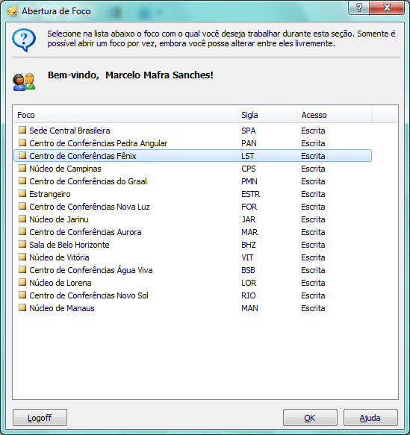

Picture 1 - "Center opening" screen.

#### Pupils related features

##### Navigation to registered pupils.

Provide a way to the user navigates to all pupils of the current center. The data is showed in a grid with some important information. The navigation can be done by two ways: alphabetic order of the name and grouped by pupils grades. The user can order the data by any information of the pupils. He can alternate between the active and inactive pupils too.

##### Register of new pupil.

Provides a way to register a new pupil. There feature only is enabled to pupils coming from abroad. This exception can be explained why the “normal pupils” always come from young people or interested public. Thus, they are registered there.

##### Change of pupil data.

Provides a way to see and change the pupil data. The feature shows only the personal data, like you can see in the screens bellow.

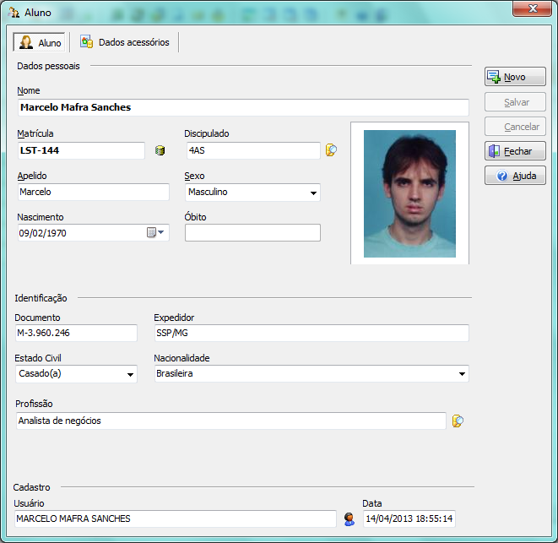

Figure 2 - Main personal information of pupil. You can see me here.

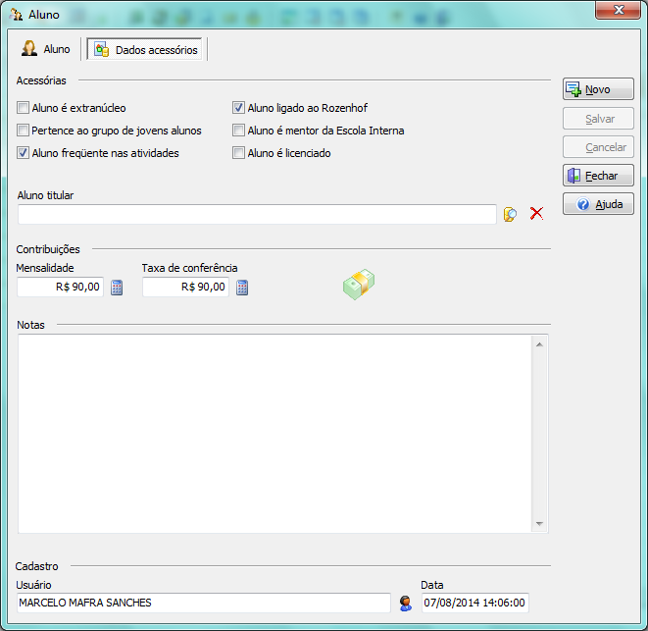

Figure 3- Additional personal information of pupil.

##### Address of pupil.

Provides a way to register the residential and commercial address of pupil. You can register how many address you want.

##### Contacts of pupil.

Provides a way to register the contacts of the pupil. Typically, contacts are phone number or emails of the pupil. You can register how many contacts you want.

##### Family of pupil.

Provides a way to register the family of the pupil. You can register how many member of family you want.

##### Diseases of pupil.

Provides a way to register the diseases of the pupil. You can register how many diseases you want.

##### Role of pupil.

Provides a way to register the roles of the pupil. You can register how many roles you want.

##### Skills of pupil.

Provides a way to register the skills of the pupil. You can register how many skills you want.

##### Transfers

Allows the registration of transfer of a pupil. The transfer occurs when a pupil decides change your linking of a center to another one.

##### Downgrading

Allow the registration of the changing of the pupil grade to another prior of this.

##### Baptism

Allows the registration of a baptism in the historic of pupil.

##### Marriage

Allows the registration of a marriage in the historic of pupil.

##### Desligamento

Allows the registration of xxxxx of a pupil of the Lectorium Rosicrucianum.

##### Religamento

Allows the registration of xxxx of an inactive pupil.

##### Carta de frequência

Allows the...

#### Historic of pupil features

##### Navigation of historic.

Provides a way to the user navigates to all records of the historic of a pupil. Since the first aspect, all occurrences are registered here. It’s possible navigate in a short or full vision of the historic of a pupil. The historic is an information share between every center, that is, it’s accessible and can be modified for different centers en different moments.

##### Change of historic of a pupil.

Provides a way to change the historic of a pupil. Typically, the changing is done by registering occurrences or “events” like marriages, baptisms, installations etc. However, you can manually do it.

##### Annulment of event of the historic of a pupil.

Provides a way to annular an event of the historic of a pupil.

#### Installations of pupils

##### Creation of installation groups.

The Cosmos system enables the installation of a people in some grade by creation of an installation group. This group can be formed by one or more members. So, every installation in an external or internal grade requires the creation of an installation group. While the candidates of the group are not installed, the users can add or exclude them. The following picture shows some groups and its members.

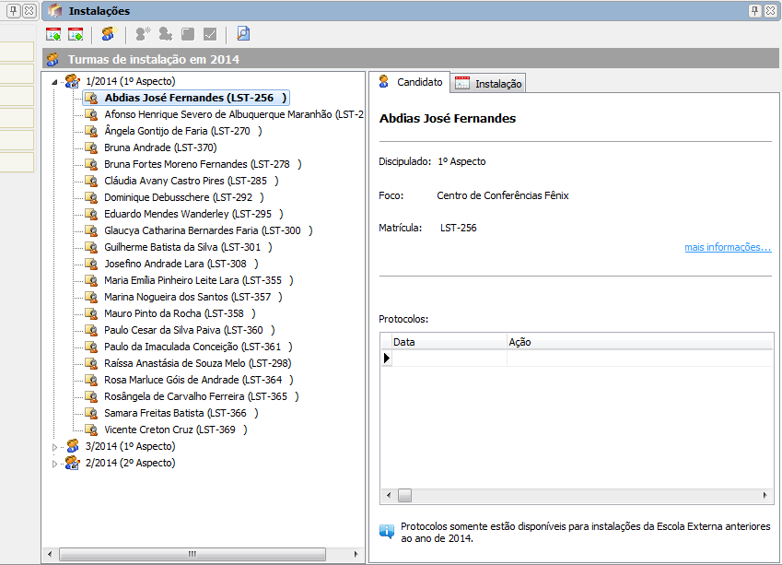

Figure 4 - Groups of candidates to first and second aspects.

##### Installation of candidates.

After the creation of the group, at some moment the candidates are ready. Then, the user installs them in the new grade. In short, this action makes two operations: change the grade and register in the historic of each candidate the event.

#### Young people related features

##### Navigation to registered youngs.

Provides a way to the user navigates to all registered youngs of the current center. The behavior of the system is identical to above.

##### Register of new young.

Provides a way to register a new young.

##### Change of young data.

Provides a way to see and change the young data. The feature shows only the personal data. The set of fields are mostly the same of the pupils, but there are some differences.

##### Address of the young.

Provides a way to register the residential and commercial address of the young. You can register how many address you want.

##### Contacts of the young.

Provides a way to register the contacts of the young. Typically, contacts are phone number or emails of the young. You can register how many contacts you want.

##### Family of the young.

Provides a way to register the family of the young. You can register how many member of family you want.

##### Diseases of the young.

Provides a way to register the diseases of the young. You can register how many diseases you want.

##### Transfers

Allows the registration of transfer of a young. The transfer occurs when a young decides change your linking of a center to another one.

##### Baptism

Allows the registration of a baptism in the historic of the young.

##### Desligamento

Allows the registration of xxxxx of a young.

##### Religamento

Allows the registration of xxxx of an inactive young.

##### Historic of the young

The historic of the young is exactly the same of a pupil. The same features are presents, but the set of types of events are others.

#### Interested people related features

##### Navigation to registered public.

Provides a way to the user navigates to all registered public of the current center. The behavior of the system is identical to above.

##### Register of new public.

Provides a way to register a new public.

##### Change of public data.

Provides a way to see and change the public data. The feature shows only the personal data. The set of fields are much different than pupil’s fields. There are informations about the origin of the public, that is, the way that the public have found the school.

##### Address of the public.

Provides a way to register the residential and commercial address of the public. You can register how many address you want.

##### Contacts of the public.

Provides a way to register the contacts of the public. Typically, contacts are phone number or emails of the public. You can register how many contacts you want.

##### Transfers

Allows the registration of transfer of a public. The transfer occurs when a public decides change his linking of a center to another one.

##### Desligamento

Allows the registration of xxxxx of a pupil of the public work.

##### Religamento

Allows the registration of xxxx of an inactive public.

##### Letters of Contact

Allows the registration the sending of letters of contact to the public. The available letters are previously registered. So, the feature was projected to support future changes.

#### Historic of public features

##### Navigation of historic.

Provides a way to the user navigates to all records of the historic of a public. It’s possible navigate in a short or full vision of the historic. The historic is an information share between every center, that is, it’s accessible and can be modified for different centers en different moments.

##### Change of historic of a public.

Provides a way to change the historic of a public. Typically, the changing is done by registering occurrences or “events” like sending of letters, installations etc. However, you can manually do it.

##### Annulment of event of the historic of a public.

Provides a way to annular an event of the historic of a public.

#### Courses and participants of the public work

##### Navigation of the groups.

Provides a way to the user navigates to all groups of courses of the public work. Each group is formed by one or more participants that take part of activities offered by public work.

##### Creation of new group.

Provides a way to create a new group of courses of the public work.

##### Register participants.

Provides a way to register the participants of a group of courses of the public work.

##### Closing of groups.

Provides a way to close a group of courses of the public work. This occurs only when a course is finished.

##### Activities of groups.

Provides a way to navigate by the activities promoted to one or more groups.

#### Supporters related features

##### Navigation to registered supporters.

Provides a way to the user navigates to all registered supporters of the current center. The behavior of the system is identical to the pupils navigation.

##### Register of new supporter.

Provides a way to register a new supporter.

##### Change of the supporter data.

Provides a way to see and change the supporter data. The feature shows only the personal data. The set of fields are much different than pupil’s fields. There are informations about the origin of the public, that is, the way that the supporter have found the school.

##### Address of the public.

Provides a way to register the residential and commercial address of the public. You can register how many address you want.

##### Contacts of the supporter.

Provides a way to register the contacts of the supporter. Typically, contacts are phone number or emails of the public. You can register how many contacts you want.

##### Transfers

Allows the registration of transfer of a supporter. The transfer occurs when a supporter decides change his linking of a center to another one.

##### Desligamento

Allows the registration of the xxxx of a supporter.

##### Religamento

Allows the registration of xxxx of an inactive supporter.

#### Internal school related features

##### Circles of the internal school.

Provides a way to navigate by the circles of the internal school.

##### New circle

Provides a way to register a new circle of internal school.

##### To update circle

Provides a way to update data of a circle of internal school. Using this feature the users can switch the mentors of the circle; define the current lesson of the circle etc.

##### Member’s circle

Provides a way to define the members of a circle. A circle can have so many members as necessary.

##### Books of internal school

Provides a way to register some data about the lessons of internal school. The user can register books and lessons related to each internal grade. There’s no support to write the contents of these lessons by no way.

##### Deactivate circle

Provides a way to deactivate a circle. Deactivated circles will not have changes in their data.

#### Activities related features

##### Schedule of activities

Provides a way to navigate by activities promoted by any center and workfield. The schedule is a central tool starting from which the users execute so much tasks like: register new activities; defines the staff of an activity; defines new activities types; performs the frequency control on activities and many others tasks.

##### New activity

Provides a way to register a new activity promoted by the current center. According to the user’s permissions, the activity can be “signed” as promoted by Lectorium Rosicrucianum, Young People, Interested Public, Public Work or Internal School. The required fields for each these activities are, in part, very similar, but there are some significant differences.

The following picture shows an activity of Lectorium Rosicrucianum.

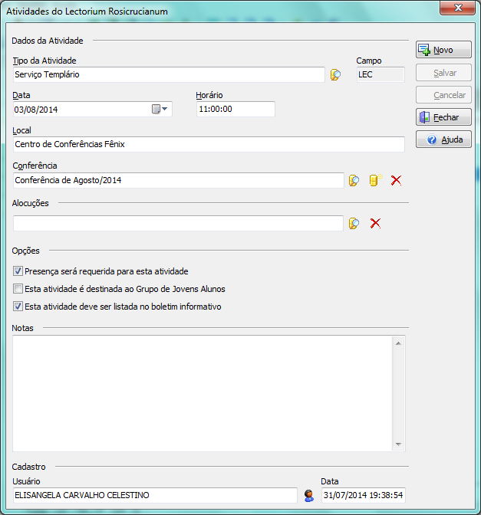

Picture 5 - Activity promoted by Lectorium Rosicrucianum.

##### Staff activity

Provides a way to register the people that work during an activity. It’s possible to define so many people as necessary. Each people perform one or more tasks.

##### Types of activities

Provides a way to define every types of activities that the system knows. Each activity is of one type and each type is franchised to a set of grades. The bellow picture show several types of activities.

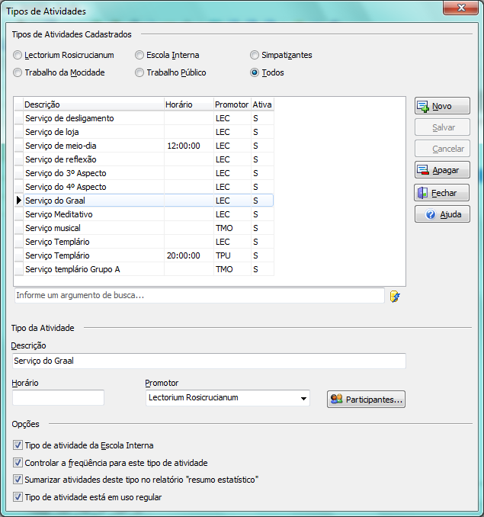

Picture 6 - Types of activities.

##### Participants

Provides a way to define the rules that define the participants of an activity. These rules are used when the system need to define who must be present in some activity. The rules are formed by three arguments:

* Activity type.
* Center that promotes the activity.
* Grades.

##### Frequency Control

Provides a way to mark if a pupil, young people or interested people have participated of an activity. The Cosmos system knows who must be present in some activity and, thus, it brings these people to the user confirms if they were present. It’s possible to justify the absence of a person. The picture bellow shows the main screen uses to perform the frequency control.

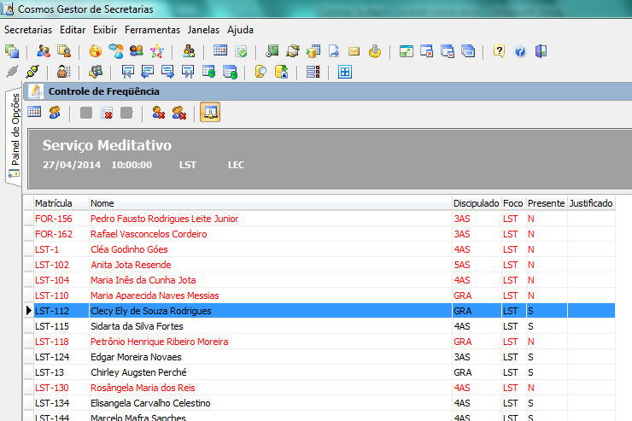

Picture 7 - Main screen used by signing the presence in activities.

### Cosmos Conferences Manager

#### Conference related features

##### Conference opening.

Provides a way to the user “open” a conference. The “conference opening” indicates that the user now wants work with some conference. Only one conference can be opened at time. The listed conferences must be promoted by the current center.

##### Conference closing.

Provides a way to the user “close” the current conference.

##### Schedule of conferences

Provides a way to the user navigate to all conferences promoted by every conferences centers. The user can select any conference and see its programming, but only will can work with those promoted by the current center.

##### New conference

Provides a way to the user create a new conference. According the user’s permissions, the user will can create a conference promoted by the Lectorium Rosicrucianum, Young People, Public Work, Interested Public or Internal School.

##### Update conference

Provides a way to the user update a conference data.

##### Conference programming

Provides a way to the user defines every activities of the conference. The set of these activities is known as “programming”.

##### Participants

Provides a way to define the rules that define the participants of each activity of the conference. These rules are used when the system need to define who must be present in some activity. The rules are formed by three arguments:

* Activity type.
* Center that promotes the activity.
* Grades.

##### Frequency Control

Provides a way to mark if a pupil, young people or interested people have participated of an conference. The Cosmos system knows who must be present in each conference’s. The criterious that must be used to control the frequency is defined when the user creates the conference.

##### Staff activity

Provides a way to register the people that work during an activity. It’s possible to define so many people as necessary. Each people perform one or more tasks.

##### Schedule of activities

The same tool used in Cosmos Gestor de Secretarias.

#### Reserves related features

##### Reserves

Provides a way to navigate by reserves of the current conference. There are several ways of do that. You can navigate between the reserves of each center; by grades; by alphabetical listing. In any of these ways, too it’s possible to filter the reserves using many rules.

##### New reserve

Provides a way to register a new reserve for the current conference. The set of fields used to create a reserve can vary greatly, according the configurations of the current center or same because the special requirement of a conference. Anyway, there are a set of fixed fields and a set defined by the user.

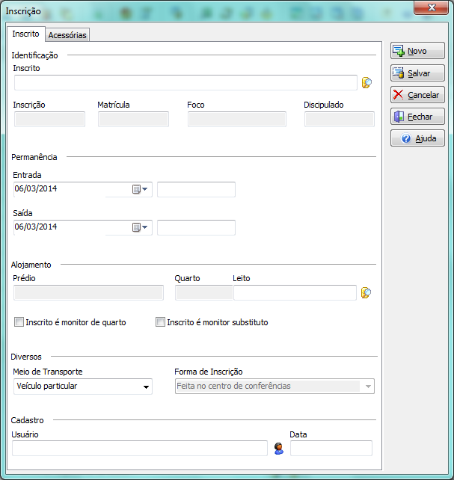

Picture 8 - New reserve screen.

##### Update reserve

Provides a way to update a reserve for the current conference

##### Import reserves

Provides a way to import many reserves from a file or previous conference. The file must be in Excel 97+ or cvs formats. It’s possible to import informations about accommodations together the reservers. All operations are performed by a wizard.

##### Accommodate reserve

Provides a way to define the accommodation of a people.

##### Print credentials

Provides a way to print the credential of a people. This is done by the checking operation.

##### Notes

Provides a way to write notes destined to a people. The notes are fixed to the reserves.

##### Reserves detailing

Provides a way to define the set of info that the user wants for the current conference. These data are stored in a structured way, thus, it’s possible to perform searchs and to create metrics about the conference using these data. All structuring of data is made using elements known as “classifiers”.

#### Accommodations related features

##### Accommodations

Provides a way to navigate by enabled accommodations of the conference center that promotes the conference. The accommodations appear of a structured way, following the structure: homes/rooms/beds.

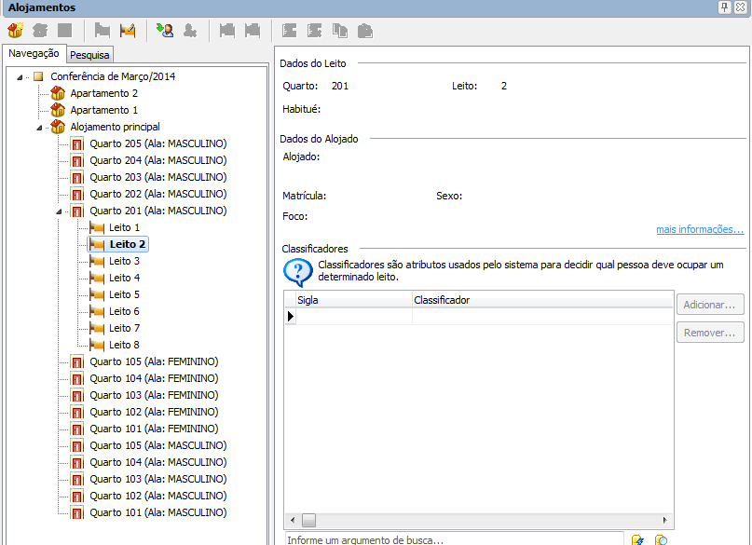

Picture 9 - Screen shows the accommodation's structure.

##### New home

Provides a way to create a new home.

##### New room

Provides a way to create a new room into a home. It’s possible define the room as “unavailable”. This instructs the system to not use the room.

##### New bed

Provides a way to create a bed into a room. It’s possible define the bed as “unavailable”. This instructs the system to not use the room. Too you can define a person as “habitué” (a “common user” of the bed).

##### Classifiers

Each bed is signed with a set of informations known like “classifiers”. Tipically, these classifiers indicates if a bed is superior; if can be used by senior citizens; if can be used by females; if can be used only by ISR or Presidium members and many others useful informations. Each bed can have so many classifiers as necessary.

##### Automatic accommodation

Allows the automatic definition of the beds that the persons will occupy during a conference. After this definition, always is possible to change the decisions.

##### Print accommodation’s list

Provides a way to print several lists relatives to accommodations.

#### Staff related features

##### Work’s areas

Provides a way to navigate over the work’s areas of the center of conference. An area is a place where several tasks are performed by different persons. Examples: temple, kitchen etc. The system provides a way for each conference center structures its set of areas, according its needs.

##### New area

Provides a way to create an area or subarea to the current conference center.

##### Update area

Provides a way to update the area data.

##### New task

Provides a way to create tasks that must be performed at an area. Each area can have so many tasks as necessary. Once again, each conference center structures its set of tasks according its needs.

##### Staff of conference

Provides a way to navigate on the persons who will work like staff in the current conference. It’s possible to see the tasks that will be performed and all work’s areas.

##### New staff

Provides a way to register the persons who will work like staff in the current conference.

##### Clone staff

Provides a way to copy the group of persons who have worked like staff in a conference previous to the current conference. It’s possible to copy the all persons or only a set.

##### Print staff list

Provides a way to print several lists relatives to staff and performed tasks.

#### Conference’s rates related features

##### Conference’s rates

Provides a way to the user register the payment of conference’s rates or others values. The pupil can pay others values, like donations for any center, for example.

### Cosmos Users Manager

To do…

### Cosmos Financial Manager

To do…

### Internationalization

The Cosmos system was developed in the Portuguese language only. However, the eventual translation of the UI for others languages is not a hard task, once that:

* All strings in the system (like messages, for example) are isolated of the code.
* The strings of the element’s screens (like menus, for example) are handled as isolated resources by the development IDE.
* The development IDE has a tool specialized to internationalization of systems. Today this tool knows only one “added language” to the system. We would add new languages and use the tool to write the translations of the elements. After this, just to compile releases for the added languages.
* Every object which needs some translation will be automatically found by the internationalization tool.
* It’s not necessary any coding to create an internationalized version of the system.

So, the great work of the internationalization is the translation itself and, certainly, the tests to verify if the translated texts still fit in the spaces of the screens and others elements.

# Architectural vision

This section describes a short architectural vision of the Cosmos system. The main architectural feature points to the multitier model. Every Cosmos applications follow this model and they are built with at least two layers: one front-end and one service or back-end.

### Front-ends

The front-ends are very light applications, built with small executables (near 200 kb) and contains all resources dedicated to a good user’s interaction. They are modern Microsoft Windows applications, using many UI elements introduced by newest versions of the operational system. There is nothing about SQL, stored procedures, database and security rules in the front-end layer. Absolutely nothing. They receive and send data using remote methods of some exposed objects from back-end layer. So, they use several objects that keep the data only in memory, including the changes made by the user. These objects are named “Client objects” and were designed to a short cycle of memory usage. These objects connect to the back-ends using specialized objects that provide the linking and traffic over TCP, HTTP or HTTPS. In the Cosmos systems, all these three elements (UI objects, data objects and connection objects) are deployed by many dynamic linking libraries.

### Back-ends

The back-ends are heavier applications and don’t have any UI elements. They are focused to provide connectivity, expose methods and properties of some classes, manipulate database objects and impose all securities rules. The business rules are found only in the remote methods of the back-ends and never in the front-end or data layers.

The back-ends can be deployed on several technologies solutions:

* Windows services;
* Webservices;
* Webservices REST application;
* Windows console applications;
* ISAPI applications for Internet Information Services;
* Apache Server web modules;

Today, they are deployed like Windows Services, but the change of the technology it’s no difficult. It’s important observe that the deploy as Windows Services has met all our needs. The high increase of users could change this scenario. The rise of new requirements related to new web or mobile clients too.

The bellow component diagram shows the macro architecture of the Cosmos systems. Some components were omitted, thus they are more relevant in a design time vision than a runtime one.

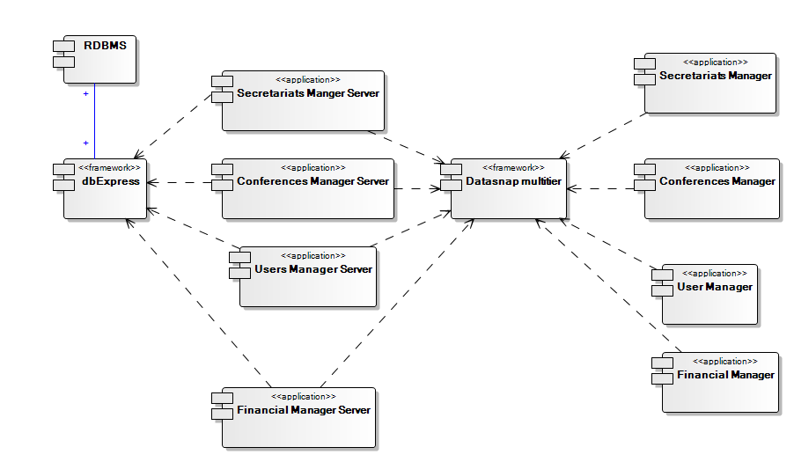

Figure 10 - Macro architecture of Cosmos system.

### Datasnap framework

The Datasnap framework is the architectural module between the client and server layers. It provides mechanisms dedicated to transport and communication, always using the operational system resources. The capacity of using the protocols TCP/IP, HTTP and HTTPS is native in the framework, that is, the applications don´t need implement anything about protocols, requiring only that they make use of these resources. The framework is deployed as a small set of libraries.

### dbExpress framework

The dbExpress framework is responsible to database operations. The framework is used only by back-ends modules. In the dbExpress, all database connectivity is available by using drivers which abstract the RDBMS’s particularities to a common set of classes and environment. Thus, you can keep the back-ends as independent as possible of the database solutions.

### Front-ends architecture

The main feature of the front-end’s architecture is the high modularity. The front-ends of the Cosmos, indeed, consist of several independent modules that are shared by all front-ends applications. These modules are deployed as dynamic link libraries and can be grouped in the following functional “categories”:

* Libraries of visual components;
* Libraries of data access components;
* Libraries that define the applications’ API;
* Libraries that define the security and connectivity API;
* Libraries that implement wizards;
* Libraries that implement forms and dialogs;

Together, these libraries sum more than 130 artifacts. The libraries of the two first categories are part of the runtime development environment libraries. The others are specific libraries of the Cosmos system. This document cannot describe each one of the libraries from an architectural perspective, but it will show only few important libraries that define the Cosmos’ API.

An important aspect of the Cosmos’ API is the intensive use of interfaces. Many interfaces are declared and exposed in the client layer for the most various proposes: access to server; access to client UI elements (menus, forms etc); use of log system; access to the security variables etc; send data to others Cosmos applications etc. The bellow diagram shows an overall vision of the core libraries of every Cosmos client application. In the picture, it’s possible see some important interfaces.

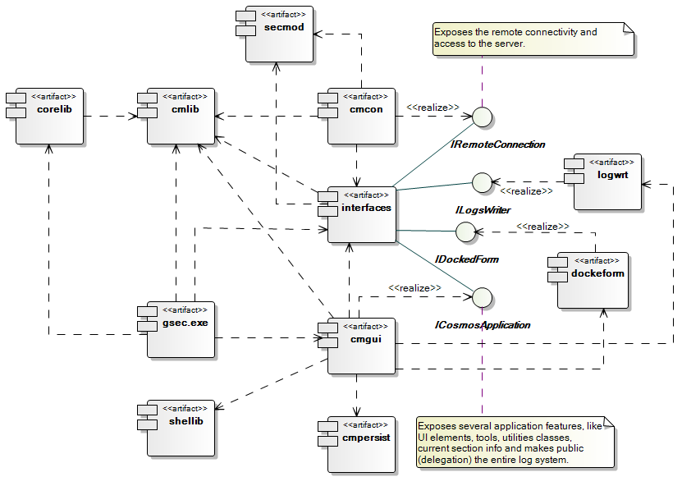

Picture 11 – Overall vision of the core libraries of the Cosmos' API.

All Cosmos client applications follow this architectural model. Detailed information about these artifacts and interfaces can be available later. For this moment, we only show some information about the two main interfaces of API through the following diagram.

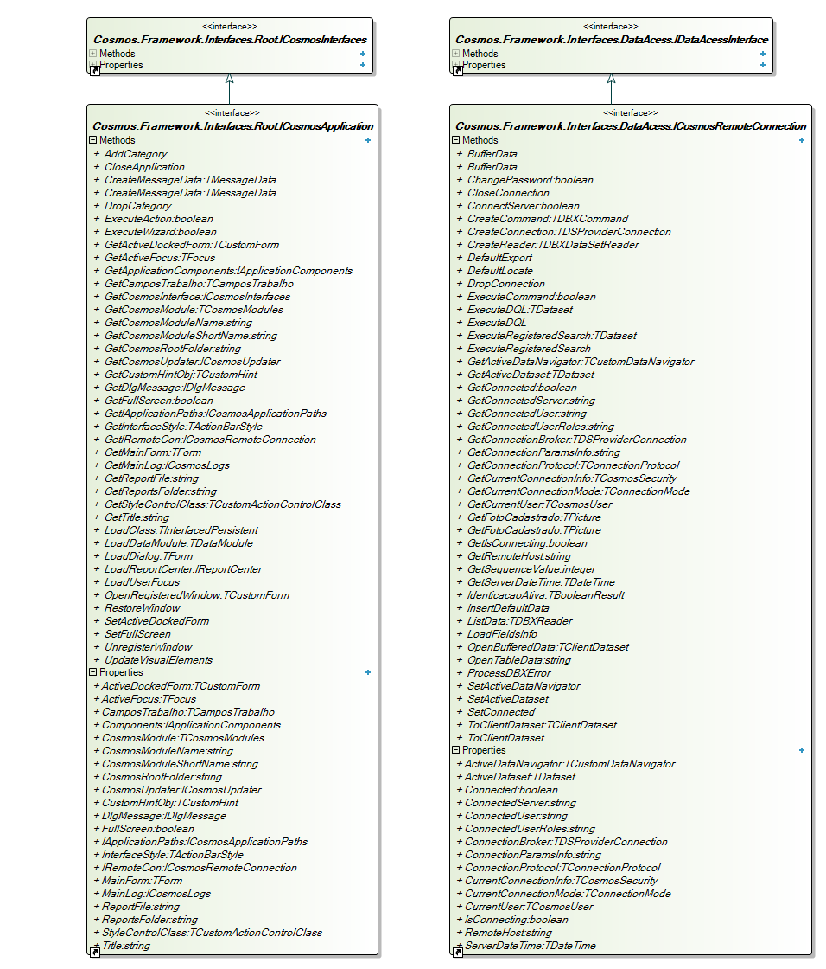

Picture 12 Interfaces ICosmosApplication and IRemoteConnection.

These interfaces expose methods and properties to work with the several features of the UI and server connectivity, respectively.

### Back-ends architecture

Unlike the client layer, the main features of the back-end’s architecture are robustness and safety. All server applications share the same security module, as well the module dedicated only to database connectivity. Each server exposes one or more business class that, in turn, exposes its methods that are signed as public methods. In this case, they can be remotely accessed by a client. The list bellow shows some business classes implemented on server applications:

* TDMSecLectoriumServerMethods – exposes methods for working with Lectorium Rosicrucianum.
* TCosmosSecEIServerMethods – exposes methods for working with Internal School.
* TDMCosmosApplicationServer – exposes methods for working with any Cosmos client application.

The security model of the back-ends allows us define which classes can be accessed by existing roles. In similar way, it’s possible to define which methods of certain class can be accessed by different roles. That definition is made dynamically by using some configurations files stored only in the server. So, each exposed class, objects or specific method must be protected of unauthorized access. There’s no way of accessing objects which are not exposed as remote class or method, like the data connection object or datasets, for example. These data relative objects are implemented in an additional software layer that is not accessible to some remote host.

The servers run on certain addresses (host plus port) and respond to the clients requests. The way that the traffic client/server is made is abstracted by the multitier framework and it’s not a relevant element in the server architecture. Finally, the servers have its life cycles defined by some important configurations.

# Physical vision

To do…

# Used technologies

This topic will report some important information about the several technologies used in the Cosmos system.

### System development

The system is written in Delphi language, using the Embarcadero RAD Studio XE4 IDE. Today, we are in migration to RAD Studio XE6. The main frameworks and packages used are:

* Visual Component Library (for Windows only solutions);
* Datasnap Multitier Framework;
* dbExpress framework;
* Rave Reports;
* Fast Reports;
* Cosmos components package (set of components developed to the project);

All these solutions are embedded in RAD Studio, except the Cosmos components package. For technical reasons, we are changing the Rave Reports to the Fast Report solution. Both are freeware software.

We yet describe the Datasnap and dbExpress solutions above. The solutions for reports are not described.

### Database system

Today we use the Firebird 2.1.3 database system, release 18185. The Firebird is a freeware software and can meet needs much more demanding than the Cosmos. The mostly recent version is Firebird 2.5.3. Soon, the version 3.0 will be deployed. Today we do not need to upgrade the system, but when the Firebird 3.0 is released we will study the gains we would with a migration.

### Deploy

The server side of Cosmos is deployed by manual copying of files and configuring the system. There’s no special task to perform. The client side must be installed using a specific system with install/uninstall capabilities. Today the Cosmos system can be installed by two different installers:

* Cosmos installer to 32 bits environments;
* Cosmos installer to 64 bits environments;

Both systems are developed using InstallShield 2010 and are Microsoft Windows Installers (MSI) packages.

### Help System

Every help system is build using the Help Maker tool.

# Data structure

The database’s Cosmos was designed to be the central repository of all centers of the spiritual school in the Brazil. It was designed to store the centers’ data of any center on a same database. From the structural perspective, we think that the database can meet the needs of any center in the world.

As the work of translating the descriptions of all tables, fields and others objects will consume many time, we can do it only in parts. So, if necessary we could add more information in each version of this document. We remember that there’s a wide data dictionary of the database, written in Portuguese language. This dictionary is a few outdated, but could be used for the moment, if necessary.

**Summary**

The database of Cosmos system has several number of objects defined in its structure. Between this objects we see tables, views, sequences etc. The picture bellow summarizes the quantity of each type of object and shows others informations.

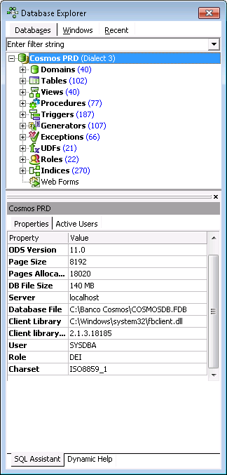

Picture 13 - Summary of objects of database.